OPERATING SYSTEMS

THE COURSEWORK "INTERPROCESS COMMUNICATION"

CONTENT

P.
1 Building a server 4
2 Building a client 7
3 Application listings 10
4 Running Application 14
5 Coursewoek variants 16

1 Building a server

For organization of the network interaction, we shall build the client-server application, which consist of client and server parts. Application will be able to work within one and two computers. Connection between client and server parts uses protocol TCP/IP. If you have one computer, client can take the address 127.0.0.1 as address of the server.
To create this application, we shall use Microsoft Visual C# 2005 or 2008.
On the File menu, point to New, and then click Project. Choose the type of the project Visual C# | Windows | Windows Form Application. In the Name field, type “Server”, choose location and click OK. You will see a Windows Form in the Windows Forms designer. This is the user interface for your application. Change Text property for the Form to “Server”.
On the View menu, click Toolbox to make the list of controls visible. Expand the Common Controls list, and drag the Button control to your form. Change Text property of button to “Start”.
Double-click the new button to open the Code Editor. Visual C# has inserted a method called button1_Click that is executed when the button is clicked.
Change this method to look like this:
private void button1_Click(object sender, EventArgs e)
{
if (started)
{
started = false;
button2.Enabled = true;
button1.Enabled = false;
}
else
{
button1.Text = "Stop";
button2.Enabled = started;
started = true;
Thread server = new Thread(new ThreadStart(startServ));
server.Start();
}
}
To allow the use of types in a namespace, add next directive into file Form1.cs:
using System.Net;
using System.Net.Sockets;
using System.Threading;
Add started field into class Form1:
bool started = false;
This field shows the state of server. To run server, the button1_Click method calls the startServ method. Insert this method after definition of button1_Click:
public void startServ()
{
IPHostEntry ipHost = Dns.Resolve("0.0.0.0");
IPAddress ipAddr = ipHost.AddressList[0];
IPEndPoint ipEndPoint = new IPEndPoint(ipAddr, 2000);
Socket sListener = new Socket(AddressFamily.InterNetwork,
SocketType.Stream, ProtocolType.Tcp);
try
{
sListener.Bind(ipEndPoint);
sListener.Listen(125);
Socket handler;
handler = sListener.Accept();
string data = null;
int sum = 0;
byte[] bytes = new byte[1024];
int bytesRec = handler.Receive(bytes);
data = Encoding.Unicode.GetString(bytes, 0, bytesRec);
string[] words = data.Split(' ');
for (int i = 0; i < 3; i++)
{
sum += Convert.ToInt32(words[i]);
}
handler.Send(Encoding.Unicode.GetBytes
("Sum of elements is "+sum));
Close();
}
catch (Exception ex)
{
MessageBox.Show(ex.Message);
}
}
The address 0.0.0.0 specifies "any IPv4 address at all". This is known to TCP programmers as INADDR_ANY.
Dns.Resolve method resolves a DNS host name or IP address to an IPHostEntry instance that contains a list of IP addresses that are associated with a host. The IPEndPoint constructor initializes a new instance of the IPEndPoint class with the specified address and port number 2000. The Socket constructor initializes a new instance of the Socket class using the specified address family, socket type and protocol. Socket.Bind associates a socket with a local endpoint. Socket.Listen places a socket in a listening state. Socket.Accept creates a new socket for a newly created connection.
As a result, we have two sockets. The sListener socket listens to the network. When server part of our application begins to work, exactly he takes request on given port from client. It accepts a received incoming attempt to create a new TCP connection from the remote client, and creates a new handler socket, associated with the socket address pair of this connection.
After the connection is established, the server receives the byte array from the client. The byte array is converted to a string and splitted in words. Each word is converted to an integer and their sum is calculated. The server sends this sum to the client.
Return to the Windows Form, and drag the second Button control to your form. Change Text property of button to “Exit”.
Windows Form will look approximately so:
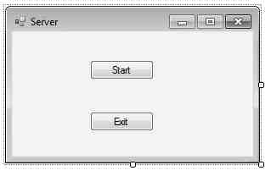

Double-click the new button. Visual C# will insert a method called button2_Click.
Change this method to look like this:
private void button2_Click(object sender, EventArgs e)
{
Close();
}
Writing the server is finished. You can build the server.

2 Building a client

Now we shall write client application.
On the File menu, point to New, and then click Project. Choose the type of the project Visual C# | Windows | Windows Form Application. In the Name field, type “Client”, choose location and click OK. Change Text property for the Form to “Client”.
Drag next controls from Toolbox to your form:
- Label with label1 Name and Connect to IP Text;
- TextBox with textBox1 Name and 127.0.0.1 Text (IP address of this computer);
- Button with button1 Name and Send String Text;
- TextBox with textBox2 Name;
- RichTextBox with richTextBox1 Name;
- Button with button2 Name and Exit Text.
When you press the Send String button, our client will send to server the data, entered by user in textBox2.
Our form will look approximately so:

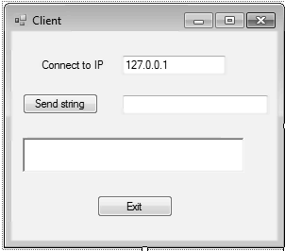

Now we shall add the code to our program. Double-click the Send String and Exit buttons. Visual C# will insert the methods called button1_Click and button2_Click, which are executed when the appropriate button is clicked.
Add next directive into file Form1.cs:
using System.Net;
using System.Net.Sockets;
using System.Threading;
Add Socket instance into class Form1:
Socket socket;
Add byte array into class Form1:
byte[] bytes = new byte[1024];
Change the button1_Click method:
private void button1_Click(object sender, EventArgs e)
{
try
{
string ip = textBox1.Text;
IPHostEntry ipHost = Dns.Resolve(this.textBox1.Text);
IPAddress ipAddr = ipHost.AddressList[0];
IPEndPoint ipEndPoint = new IPEndPoint(ipAddr, 2000);
socket = new Socket(AddressFamily.InterNetwork,
SocketType.Stream, ProtocolType.Tcp);
socket.Connect(ipEndPoint);
socket.Send(Encoding.Unicode.GetBytes(textBox2.Text));
int bytesRec = socket.Receive(bytes);
string str = Encoding.Unicode.GetString(bytes, 0,
bytesRec);
richTextBox1.Text = str;
}
catch(Exception ex)
{
MessageBox.Show("Unable to connect to Server\n" +
ex.Message);
}
}
Change the button2_Click method:
private void button2_Click(object sender, EventArgs e)
{
Close();
}

Writing the client is finished. You can build the client.

3 Application listings

For convenience, we present the full listings of client-server application.
The file Form1.cs for Server has form.

using System;
using System.Collections.Generic;
using System.ComponentModel;
using System.Data;
using System.Drawing;
using System.Text;
using System.Windows.Forms;
using System.Net;
using System.Net.Sockets;
using System.Threading;

namespace Server
{
public partial class Form1 : Form
{
bool started = false;

public Form1()
{
InitializeComponent();
}

private void button1_Click(object sender, EventArgs e)
{
if (started)
{
started = false;
button2.Enabled = true;
button1.Enabled = false;
}
else
{
button1.Text = "Stop";
button2.Enabled = started;
started = true;
Thread server = new Thread(new ThreadStart(startServ));
server.Start();
}
}

public void startServ()
{
IPHostEntry ipHost = Dns.Resolve("0.0.0.0");
IPAddress ipAddr = ipHost.AddressList[0];
IPEndPoint ipEndPoint = new IPEndPoint(ipAddr, 2000);
Socket sListener = new Socket(AddressFamily.InterNetwork,
SocketType.Stream, ProtocolType.Tcp);
try
{
sListener.Bind(ipEndPoint);
sListener.Listen(125);
Socket handler;
handler = sListener.Accept();
string data = null;
int sum = 0;
byte[] bytes = new byte[1024];
int bytesRec = handler.Receive(bytes);
data = Encoding.Unicode.GetString(bytes, 0, bytesRec);
string[] words = data.Split(' ');
for (int i = 0; i < 3; i++)
{
sum += Convert.ToInt32(words[i]);
}
handler.Send(Encoding.Unicode.GetBytes
("Sum of elements is "+sum));
Close();
}
catch (Exception ex)
{
MessageBox.Show(ex.Message);
}
}

private void button2_Click(object sender, EventArgs e)
{
Application.Exit();
}

}
}

The file Form1.cs for Client has form.

using System;
using System.Collections.Generic;
using System.ComponentModel;
using System.Data;
using System.Drawing;
using System.Text;
using System.Windows.Forms;
using System.Net;
using System.Net.Sockets;

namespace Client
{
public partial class Form1 : Form
{
Socket socket;

public Form1()
{
InitializeComponent();
}

byte[] bytes = new byte[1024];

private void button1_Click(object sender, EventArgs e)
{
try
{
string ip = textBox1.Text;
IPHostEntry ipHost = Dns.Resolve(this.textBox1.Text);
IPAddress ipAddr = ipHost.AddressList[0];
IPEndPoint ipEndPoint = new IPEndPoint(ipAddr, 2000);
socket = new Socket(AddressFamily.InterNetwork,
SocketType.Stream, ProtocolType.Tcp);
socket.Connect(ipEndPoint);
socket.Send(Encoding.Unicode.GetBytes(textBox2.Text));
int bytesRec = socket.Receive(bytes);
string str = Encoding.Unicode.GetString(bytes, 0,
bytesRec);
richTextBox1.Text = str;
}
catch(Exception ex)
{
MessageBox.Show("Unable to connect to Server\n" +
ex.Message);
}
}

private void button2_Click(object sender, EventArgs e)
{
Close();
}

}
}

4 Running Application

Run the server application and click the Start button. Text on the button will be changed to the text “Stop”, and socket will begin to listen for incoming connection.
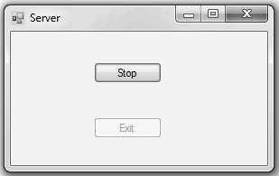
Run the client application. If server is running at the same machine, leave IP address unchanged, else correct “127.0.0.1” to the real server IP address. In second TextBox, type three integers, splitted with space.
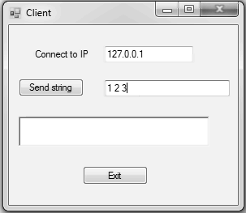

After processing, server returns to client the sum of integers. The sum will be represented in RichTextBox, as is shown below.

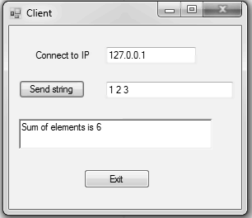

5 Coursework variants

Write client-server application for interprocess communication through sockets using Visual C#.
Variants of the communication.
№ | Client sends to server: | Server returns to server:
1 | number | acknowledgement
2 | three numbers | the sum of these numbers
3 | three numbers | the product of these numbers
4 | three numbers | maximum of these numbers
5 | three numbers | minimum of these numbers
6 | matrix [3×3] | sum of the elements of the matrix
7 | matrix [3×3] | the maximum element of the matrix
8 | matrix [3×3] | the minimum element of the matrix
9 | matrix [3×3] | quantity of the zero elements of the matrix
10 | matrix [3×3] | the sum of the positive elements of the matrix
11 | matrix [3×3] | the sum of the negative elements of the matrix
12 | matrix [3×3] | the sum of the diagonal elements of the matrix
13 | multi-word string | number of words in the string
15 | multi-word string | number of spaces in the string
16 | multi-word string | number of letters in the string
17 | multi-word string | number of digits in the string
18 | multi-word string | the first word in the string
19 | multi-word string | the last word in the string
20 | multi-word string | number of symbols “s” in the string

